22.20: a) For points outside a uniform spherical charge distribution, all the charge can be considered to be concentrated at the center of the sphere. The field outside the sphere is thus inversely proportional to the square of the distance from the center. In this case:
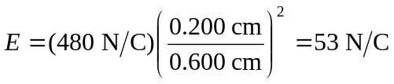
b) For points outside a long cylindrically symmetrical charge distribution, the field is identical to that of a long line of charge:
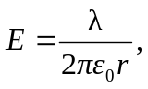
that is, inversely proportional to the distance from the axis of the cylinder. In this case
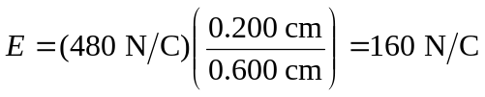
c) The field of an infinite sheet of charge is 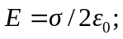 i.e., it is independent of the distance from the sheet. Thus in this case 